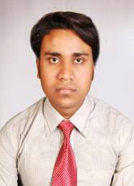
CURRICULUM VITAE
DHANANJAY CHOUDHURY
Durganagar (MQ-135)
Brajrajnagar,
Jharsuguda,
ODISHA- 768216
E mail ID:dhananjay.brjn@gmail.com
Mobile:8085481181/9124418882
CAREER OBJECTIVES

To be part of an organization where I can apply my knowledge, learn new technique and acquire new skills, to be able to build an organization of my own and contribute constructively for the betterment of the society.
EDUCATIONAL QUALIFICATIONS
- First Division B.Tech In Mechanical Engg. With 7.3 CGPA From Aryan Institute Of Engg & Technology , Bbsr,Odisha In 2015

- First Division Diploma in Mechanical Engg. With 75% of mark from R.I.T. Kalunga, Rourkela in 2012 .

- Third Division in C.H.S.E with 49% of mark from B.N. College Brajrajnagar in 2008.

- Third Division in H.S.C with 45% of mark from Orient Colliery High School Brajrajnagar Jharsuguda Odisha in 2006.
EXPERIENCE

- Previously Working as a junior Engg at MSP Metallics LTD. In pellet Benefication plant.jharsuguda, Odisha,from 21 April 2012 to Nov 2014
- Now Working as a Sr. Engineer at Rashi Steel & Power Ltd in pellet Benefication plant , Bilaspur,Chhattisgarh from 14 Nov 2014 to till date.
- JOB RESPONSIBILITY:- Mechanical Maintenance Shift in-Charge in pellet Benefication plant.
COMPUTER SKILL
- Course-ADCA from NICE-Center, Brajrajnagar
PERSONAL PROFILE
Name- DhananjayChoudhury
Father’s Name- PremNathChoudhury
Date of Birth- 12.005.1991
Sex- Male
Marital status- Unmarried
Nationality- Indian
Hobbies- Listening music,browsing,talking
Language efficiency- Hindi, English, Oriya
PERMANENT ADDRESS

Durganagar, Brajrajnagar,Jharsuguda, Odisha

PHONE NO. - 8085481181/9124418882
DECLARATION

I hereby declare that the details furnished above are true to the best of my knowledge and belief, and I bear the responsibility for the correctness of the above mentioned particulars.
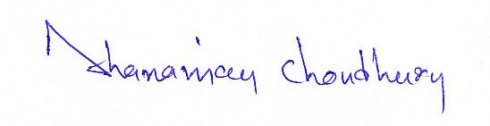

Place: Brajrajnagar DHANANJAY CHOUDHURY

